Mid Term Exam

Creating Biomedical Knowledge Graph
Alternative Approach to PrimeKG
Wijesh Kumar
MS DS 3rd Semester
Bioinformatics
Submitted to :
Dr Muhammad Ishaq
Date of Submission: 12-04-2026

Contents
1. Introduction 3
2. Methodology 3
3. Data Resources (Repositories) 4
4. Node Types 4
5. Attributes of Knowledge Graph 5
6. Attributes of Knowledge Graph 5
7. Visualization of Knowledge Graph 6
8. Validation Results 7
2nd Knowledge Graph: Clinical Context¶ 8
Visualization of Knowledge Graph: Clinical Context 8
Validation of Knowledge Graph: Clinical Context 8
Conclusion 9

1. Introduction
This demo project is focusing on creating the knowledge graph an alternative approach to PrimeKG using csv format dataset of diseases, drugs, and genes (For this project diseases are used that are common in our country). In addition to this an extended Graph knowledge graph is also created that focuses on Clinical Context in which symptoms and risk factors are incorporated.
This project is developed using python in jupyter Notebook.

2. Methodology
Key steps to Build the knowledge Graph
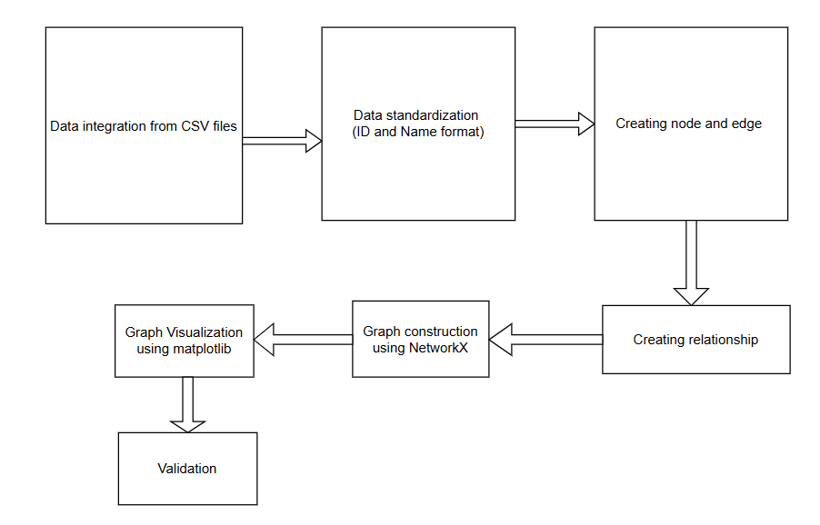
Tools Used
- Python Programming Language
- Jupiter notebook development environment
- Pandas Python Library
- NetworkX Library for construction of Graph
- Matplotlib Library for visualization

3. Data Resources (Repositories)
- For this project Following CSV files are used that contain 30 records of each disease, Drug and genes also some records of symptoms and risk factors are also used for extended knowledge graph.
Local CSV Datasets
- diseases_pakistan.csv
- drugs.csv
- genes.csv
Extended Synthetic Datasets
- symptoms.csv
- risk_factors.csv

4. Node Types
For this project Main nodes are Diesease , Drug and Gene. For Extended Knowledge Graph Symptom and Risk Factor are used.
Main Nodes:
- Disease
- Drug
- Gene
Extended Nodes:
- Symptom
- Risk Factor
These nodes represent both molecular-level and clinical-level information.

5. Attributes of Knowledge Graph
Each node contains the following attributes:
- node_id (Unique identifier of Node)
- node_name (Node name)
- node_type (Category of Node i.e Disease, Drug, Gene, etc.)
These attributes ensure proper identification and classification of entities within the knowledge graph.

6. Attributes of Knowledge Graph
For this project total 6 relationships are used.
Main Relationships:
- Drug treats the Disease
- Gene is associated_with with Disease
- Drug targets the Gene
Extended Relationships
- Disease (has_symptom) Symptom
- Disease (caused_by) Risk Factor
- Risk Factor (increases_risk) Disease
These relationships capture both biological interactions and clinical associations in the knowledge Graph.

7. Visualization of Knowledge Graph
Following are Screenshot of Knowledge Graph of
1. Knowledge Graph overall
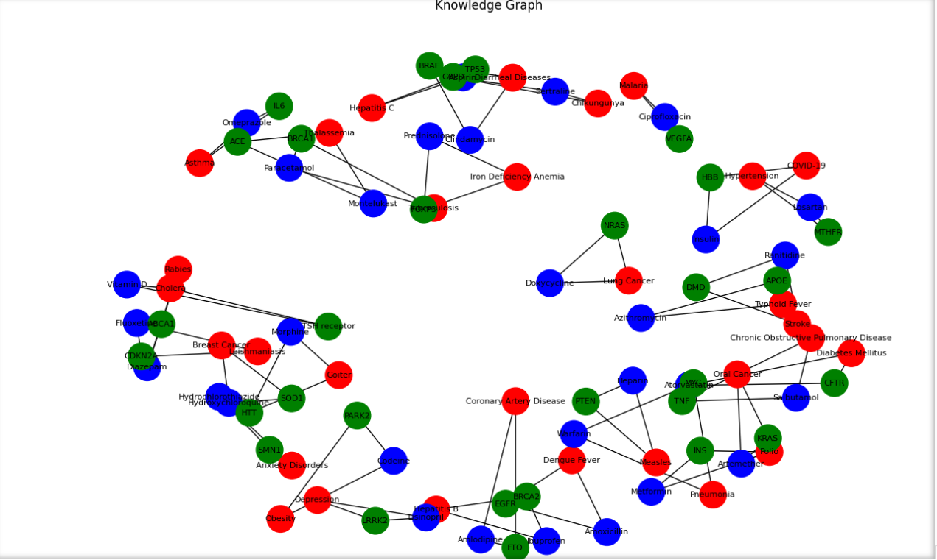
Red color shows the Disease, Blue color shows the Drug and Green color is used for Gene Node.
2. Knowledge Graph of some Disease Nodes is shown
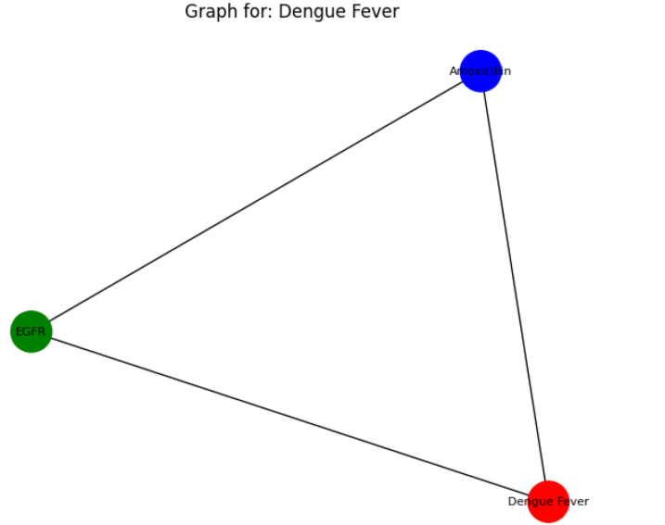
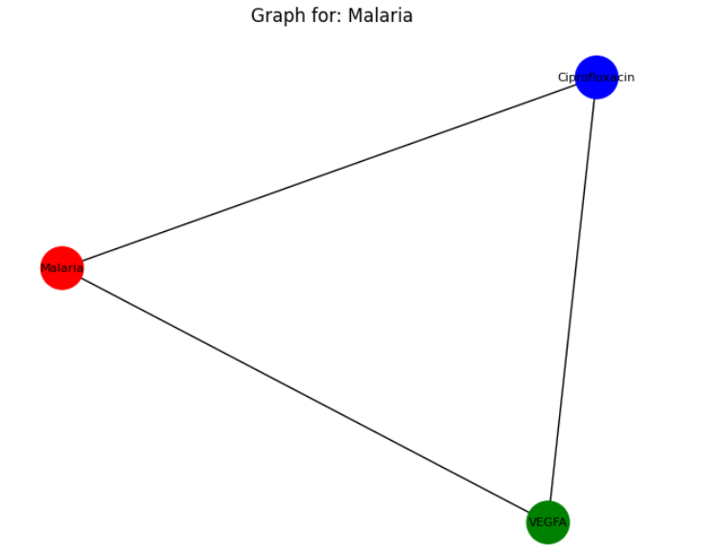

8. Validation Results
Screenshot output of Validation results is shown


2nd Knowledge Graph: Clinical Context¶

Visualization of Knowledge Graph: Clinical Context
Two More nodes are added in this knowledge Graph (Orange color is used for symptoms and purple color is used for risk factors)
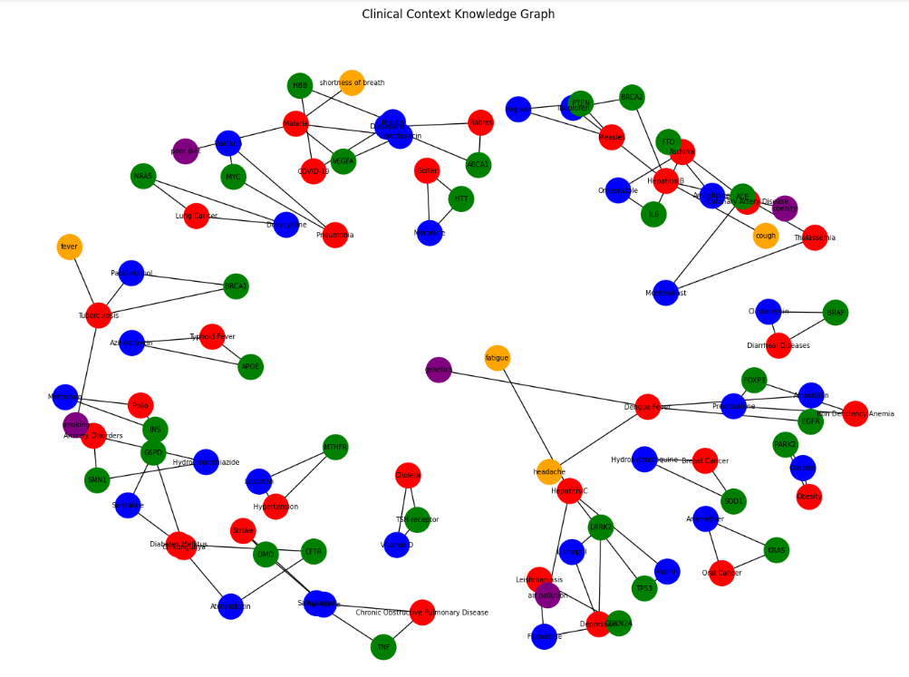

Validation of Knowledge Graph: Clinical Context
The Screenshot of validation results is shown below
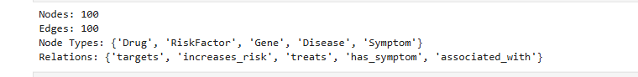

Conclusion
This demo project successfully created a biomedical knowledge graph an alternative approach to PrimeKG. PrimeKG used a complex database but here in this approach simple dataset were used to create the knowledge graph of schema to integrate diseases, drugs, and genes into a unified structure. And extended clinical graph is also created by adding the symptoms and risk factors. This use of data driven approve made possible to create the efficient knowledge graph using the python libraries from the csv dataset.
Overall, this project shows how knowledge graph can simply the complex biomedical information and make help in decision making. This project is scalable to larger dataset.

